Procedure to fix the TYPE_E_CANTLOADLIBRARY error
The following error appears when Jasperactive tries to open a Word, Excel, PowerPoint, Access or Outlook exercise.
Often occurs when you uninstall Microsoft Office 32 bits and then install a 64 bits version or vice versa; this leaves residues in the Windows registry causing the following error message:
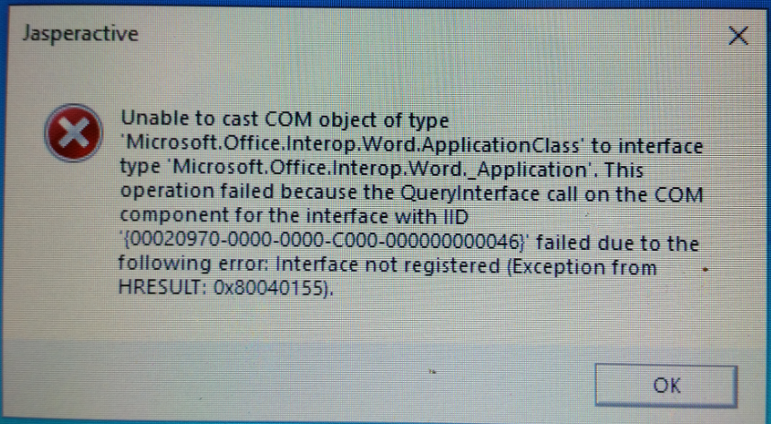
Before following the steps below it is suggested to create a restore point of the computer to return to it in case you delete keys incorrectly.
To solve it follow the following steps:
1. Open Microsoft Word – Click on File and then select “Account” on the left-hand side, when the Account Screen opens click on About Word
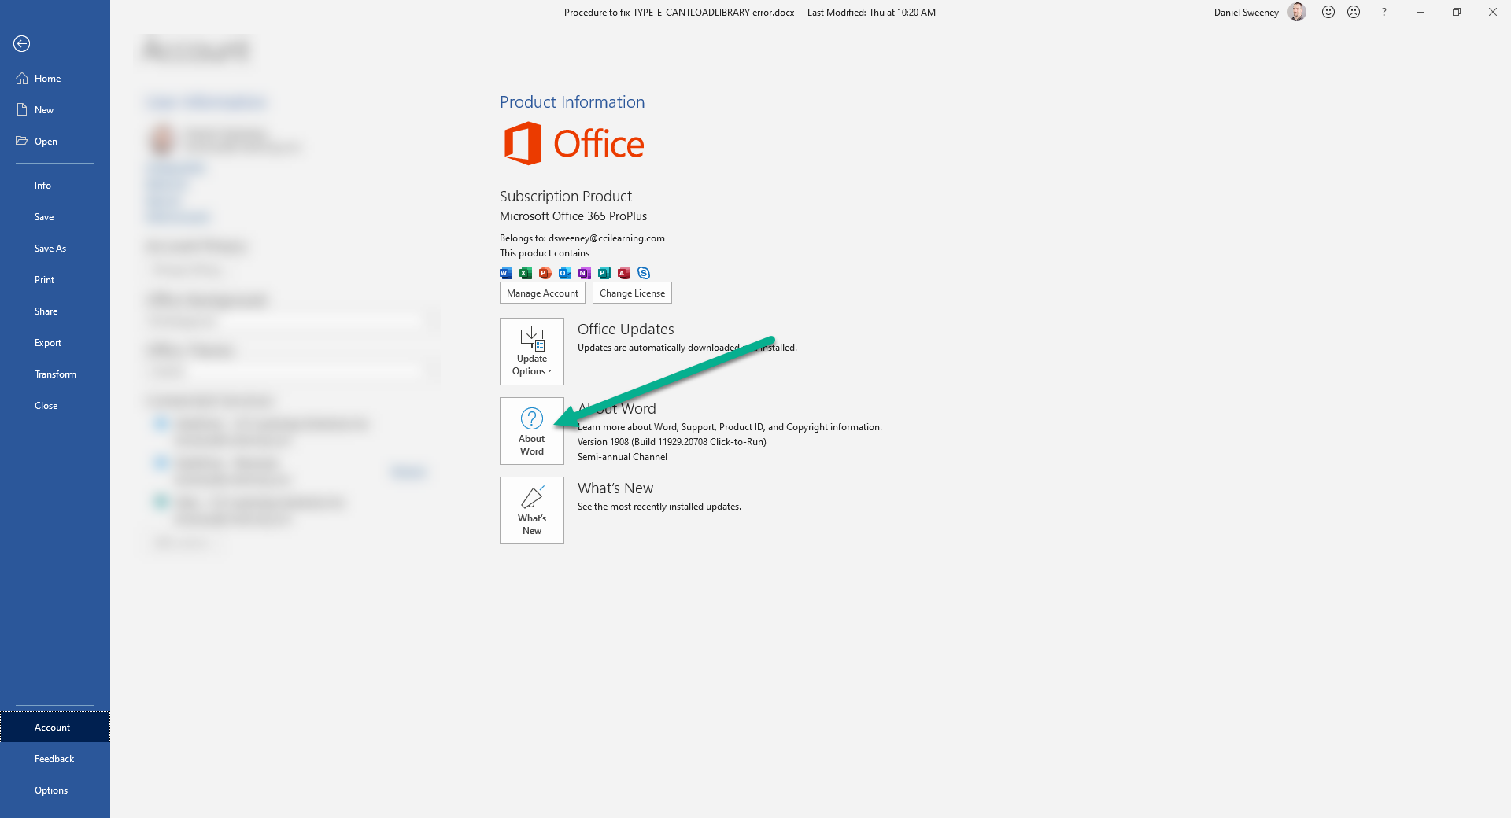
2. identify the version of Microsoft Word installed. (it will be either 32 or 64 bit)
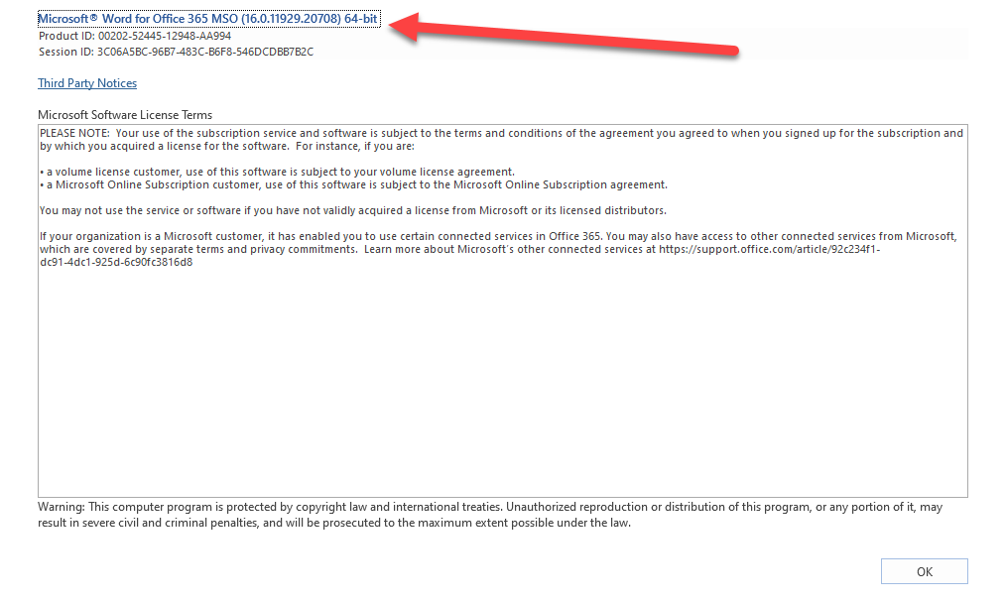
3. Click Ok to close this window
4. Open the Task Manager – Right click on Microsoft Word and then select “Open File Location”
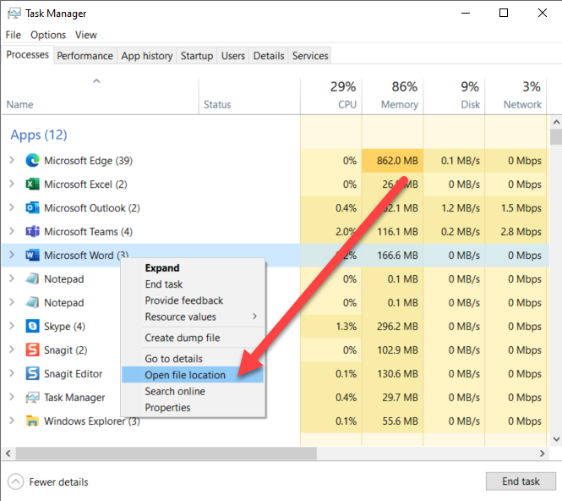
The default location for Office 365 should be:
C:\Program Files\Microsoft Office\root\Office16
5. In the Search box type in *.OLB
These are the files we need to Re-Register
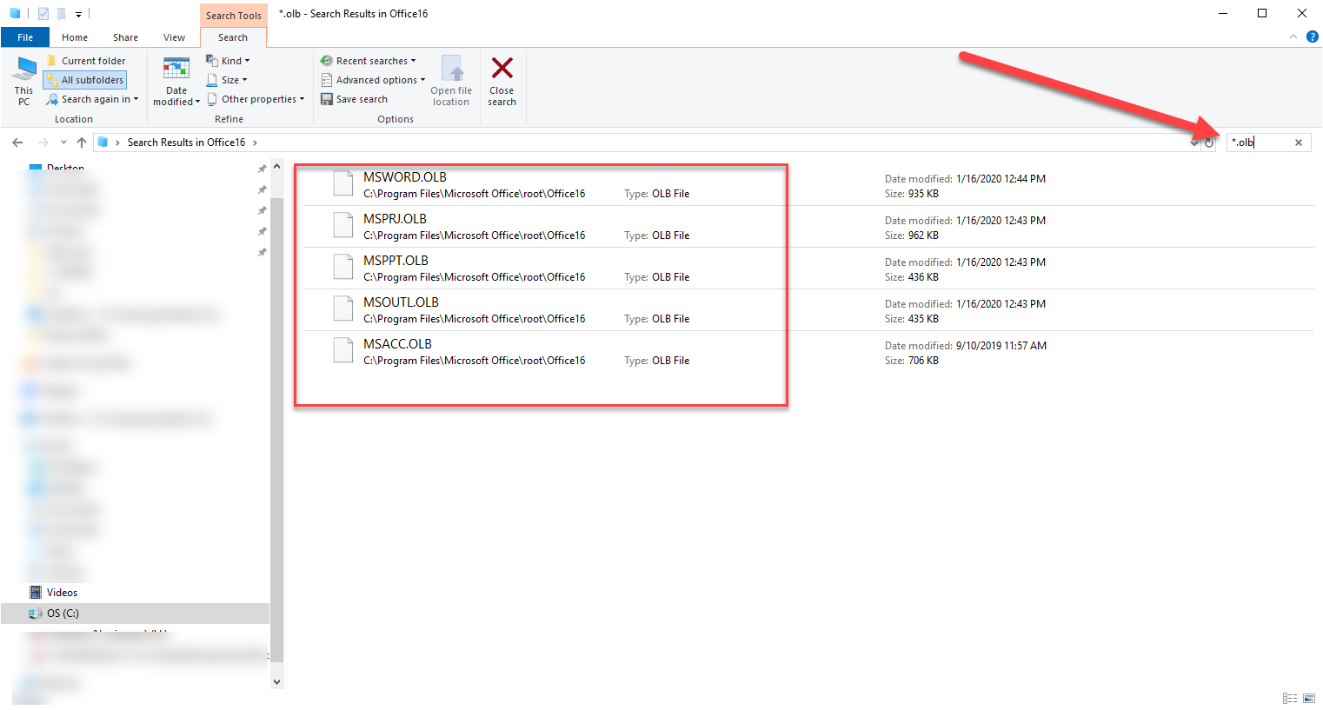
Leave this window open and we will now get the system ready, depending on the version of Office you will need either
regtlibv12_32.exe OR regtlibv12_64.exe
- Copy the file you require to the computer

- Navigate to C:\Windows\Microsoft.NET\Framework64 and locate the latest version of .Net Framework and open the folder

  - At the time of writing this article the default is: C:\Windows\Microsoft.NET\Framework64\v4.0.30319
  - Copy the regtlibv12_64.exe into this folder
  - 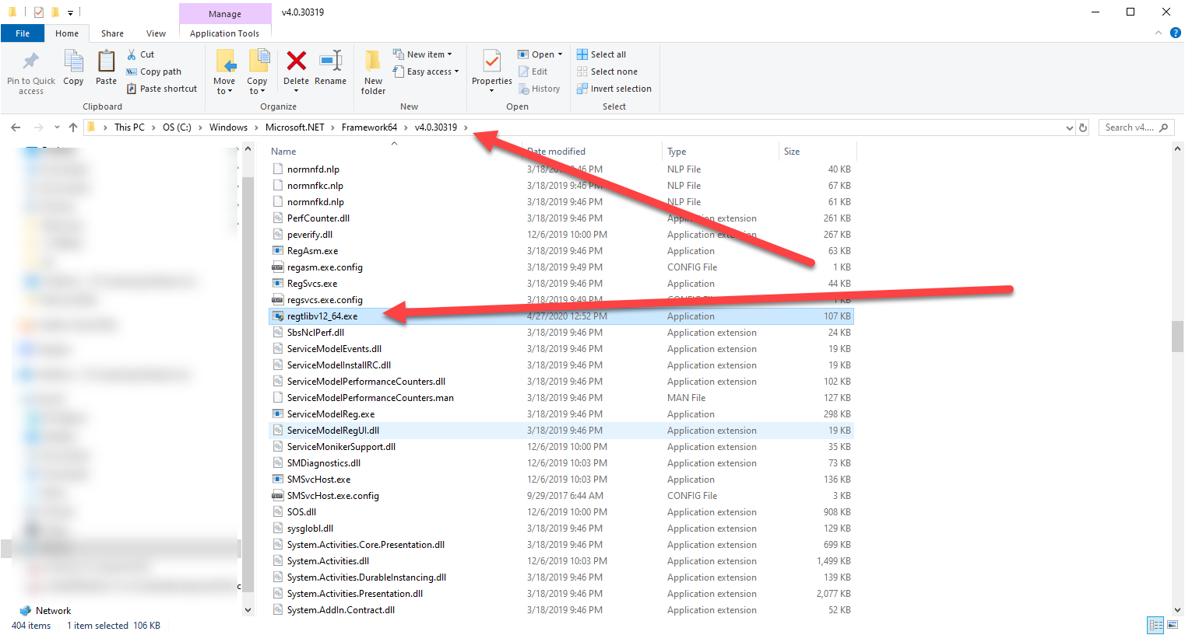

- Open a Command with Administrator Rights
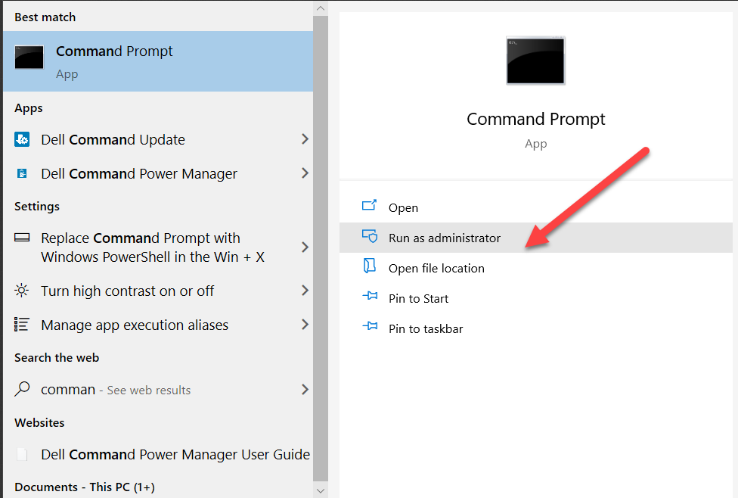
- Use the CD command and change the default directory to:
  - cd C:\Windows\Microsoft.NET\Framework64\v4.0.30319
  - 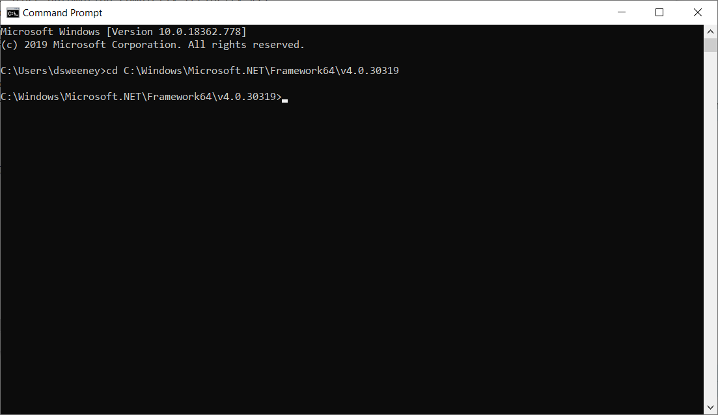
- Next, switch back to Windows Explorer with the *.OLB files and select the first one
  - C:\Program Files\Microsoft Office\root\Office16
- Make sure all Office Applications are now CLOSED
- With the first OLB file selected, on the HOME tab click on Copy Path
- Return to the command prompt
- Type in regtlibv12_64.exe and then right click and Paste the Path – should look like this:
  - regtlibv12_64.exe "C:\Program Files\Microsoft Office\root\Office16\MSWORD.OLB"
  - regtlibv12_64.exe "C:\Program Files\Microsoft Office\root\Office16\MSPPT.OLB"
  - regtlibv12_64.exe "C:\Program Files\Microsoft Office\root\Office16\MSOUTL.OLB"
  - regtlibv12_64.exe "C:\Program Files\Microsoft Office\root\Office16\MSACC.OLB"
  - regtlibv12_64.exe “C:\Program Files\Microsoft Office\root\Office16\EXCEL.EXE”
- Once completed Close the Command Prompt and try to launch Jasperactive again.

