Open Microsoft PowerPoint and then click on Options
When the Options dialog box opens click on Add-ins on the left-hand side.
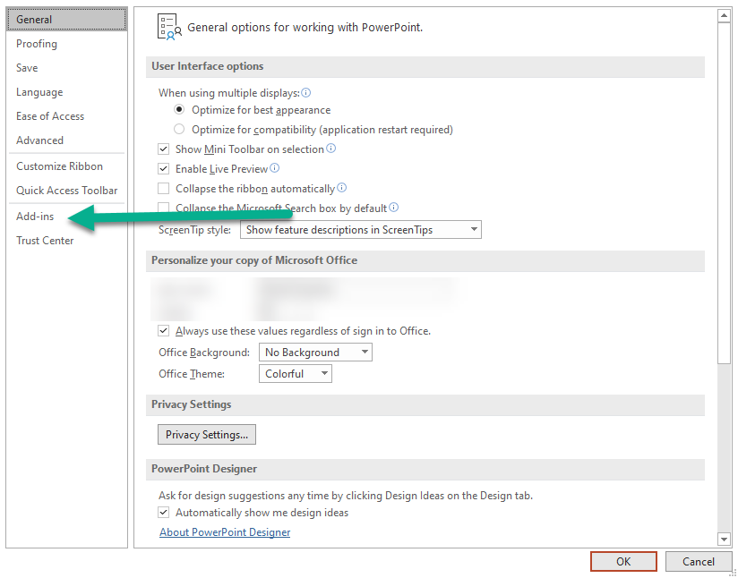
Make sure it says COM Add-Ins and then click on GO
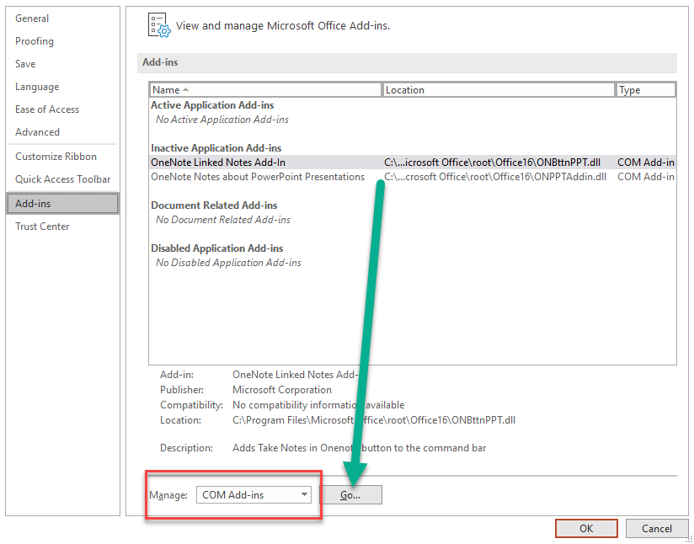
Uncheck any Com Add-ins that might have a checkmark and then Click OK
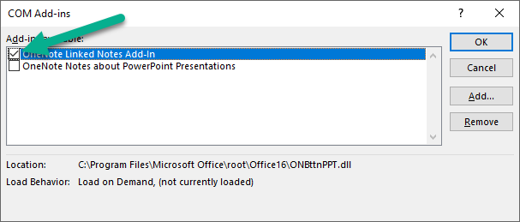

Close PowerPoint and try Jasperactive again

