Procedure to fix the TYPE_E_CANTLOADLIBRARY error
The following error appears when Jasperactive tries to open a Word, Excel, PowerPoint, Access or Outlook exercise.
Often occurs when you uninstall Microsoft Office 32 bits and then install a 64 bits version or vice versa; this leaves residues in the Windows registry causing the following error message:
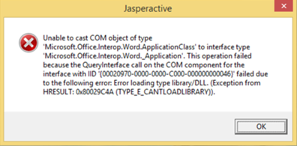
Before following the steps below it is suggested to create a restore point of the computer to return to it in case you delete keys incorrectly.
To solve it follow the following steps:
- Open the windows registry by pressing the Windows key + R (at the same time)
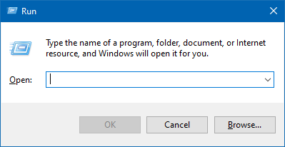
- Type "regedit" and press enter
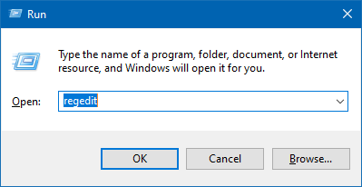
Open the Edit menu and click on the Find...
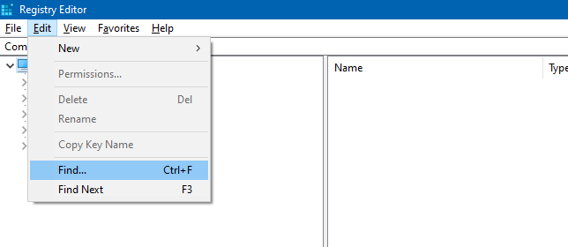
- In the window that appears, type the key shown in the error window, in this case it is:
00020970-0000-0000-C000-000000000046
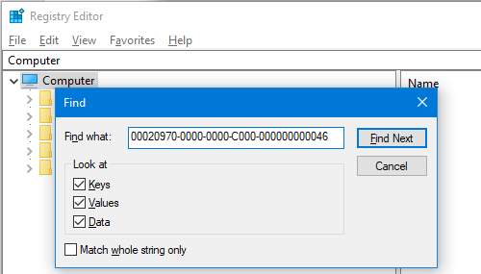

- Click on Find Next and wait for the program to find the key
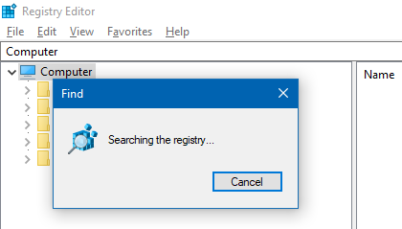
- Expand the 00020970-0000-0000-C000-000000000046 key and select the TypeLib subkey
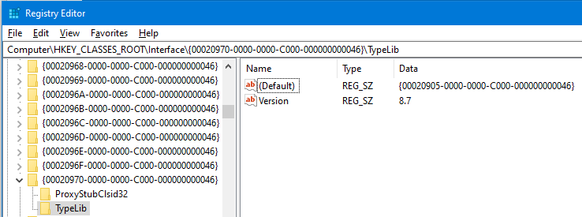
Important: Consider the value of the Default row as It will be referenced in the following steps.
- Double-click on the Default row in the Name column and copy the value from the pop-up window
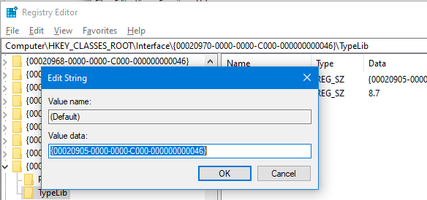
- Close the search window and type the address bar as follows:
Computer\HKEY_CLASSES_ROOT\TypeLib\<Value copied in the previous step>
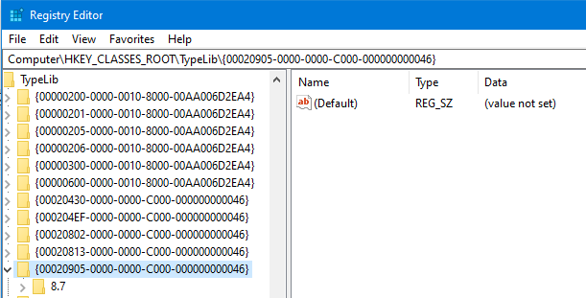
- Press enter and expand the key as shown in the image
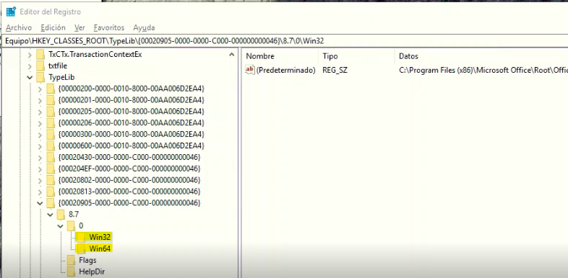

- Within key 0, there are two subkeys Win32 and Win64, delete the key that does not correspond to your Office installation.
To find out what type of installation is your Office, open Microsoft Word, click on Account, then click About Word.
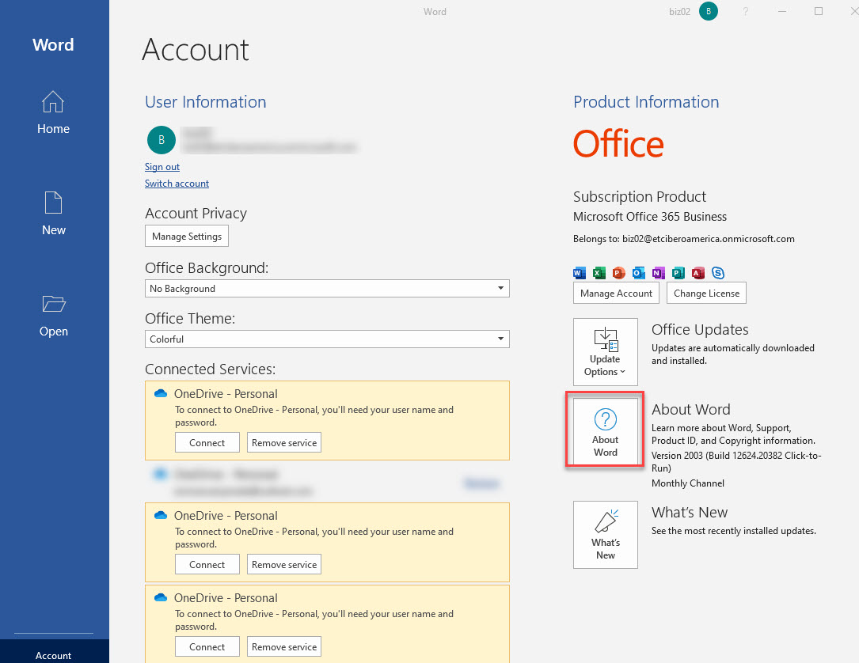
- In the window that appears locate the type of installation. In this case the type of installation is 32 bits.

- According to this case, we must delete the key Win64
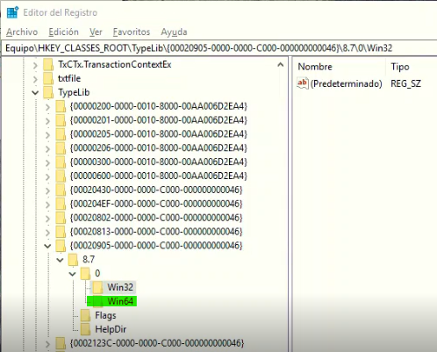
Note 1: to delete a subkey, click on it and choose the Delete option.

- Open Jasperactive again and verify the correct operation.

